MANISH PATEL – SUBMISSION OF THE PROJECT FOR JAVA/JEE OPENING

IN MEMORY DATA USED: H2 🡪 Correctly configured and data populated using data.sql by keeping in resources folder.

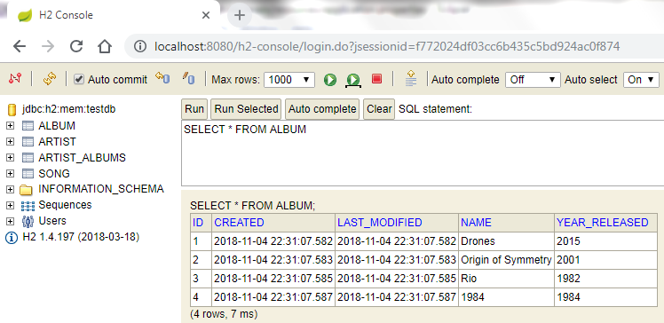

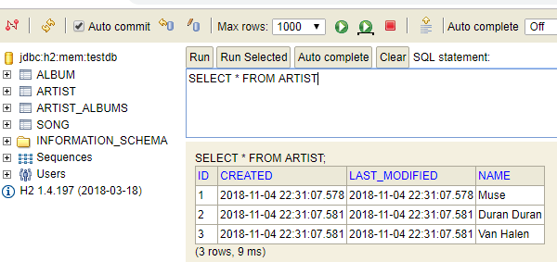

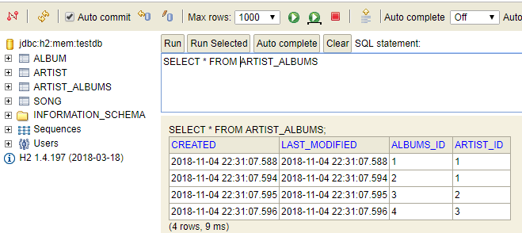

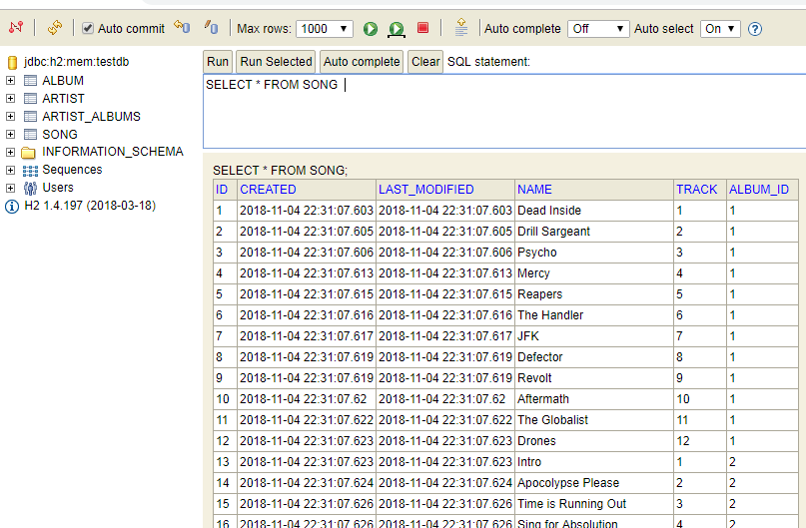

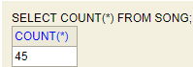

Java Code structure/packages

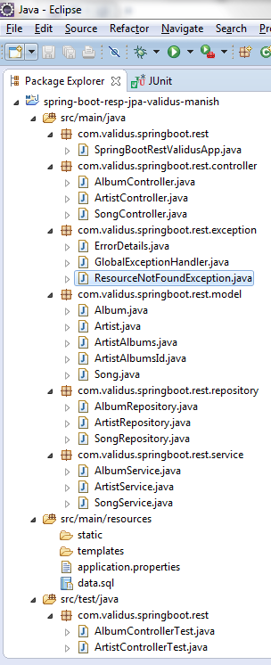

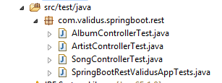

Used **POSTMAN** app of Google Chrome to test request and response

**GET ARTIST BY ID:**

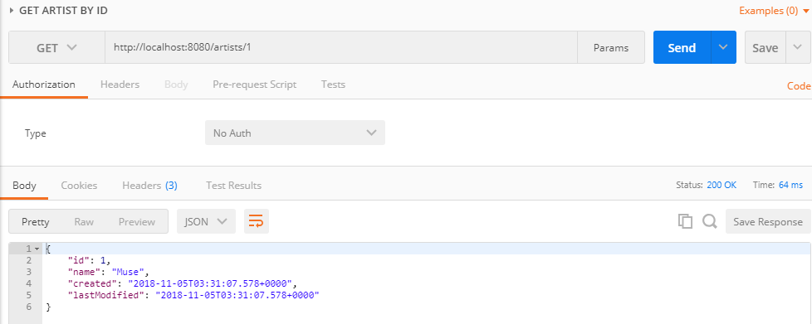

**GET ALL ARTISTS:**

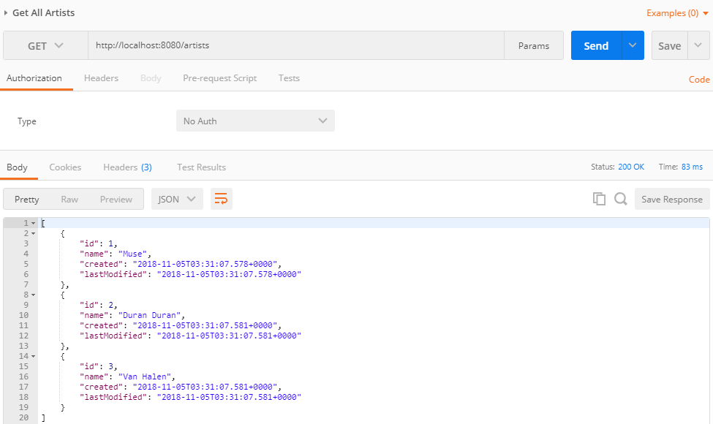

**ARTIST NOT FOUND: NEGATIVE SCENARIO**

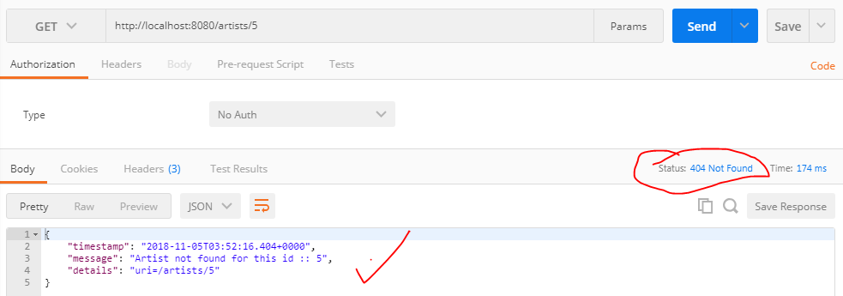

**ARTIST DELETE BY ID:**

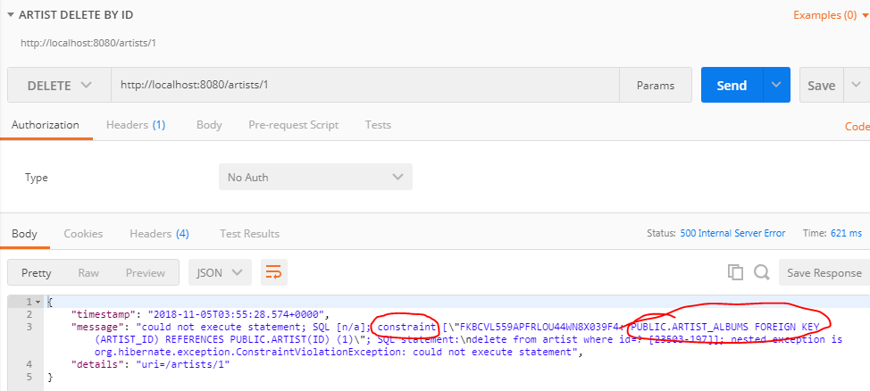

**ARTIST PUT/UPDATE BY ID:**

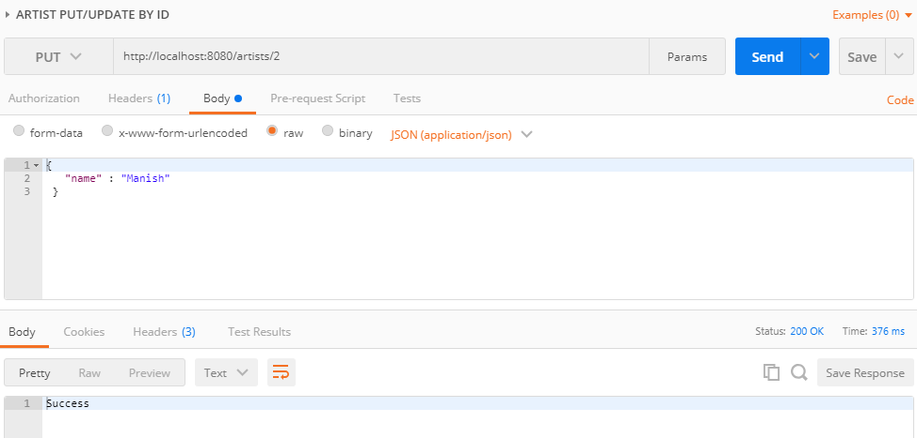

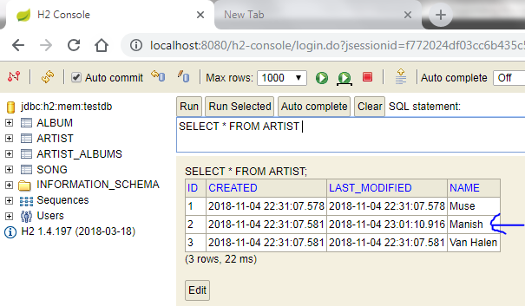

**ARTIST CREATE / POST:**

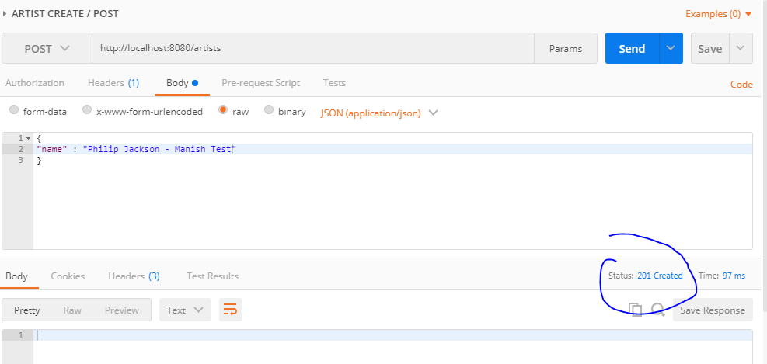

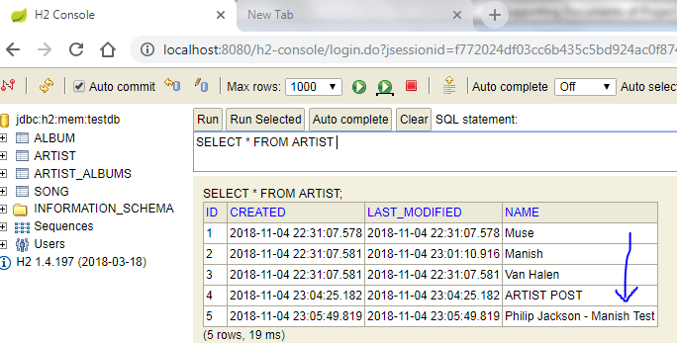

**GET SONG BY ID:**

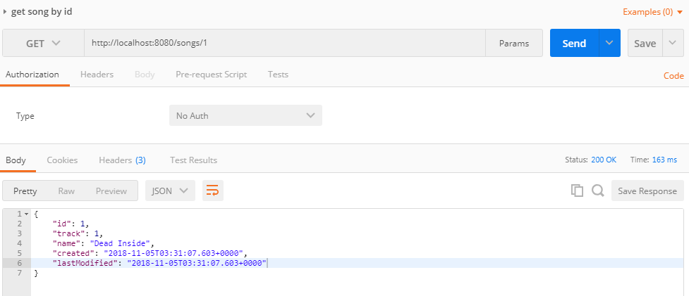

**GET ALL SONGS:**

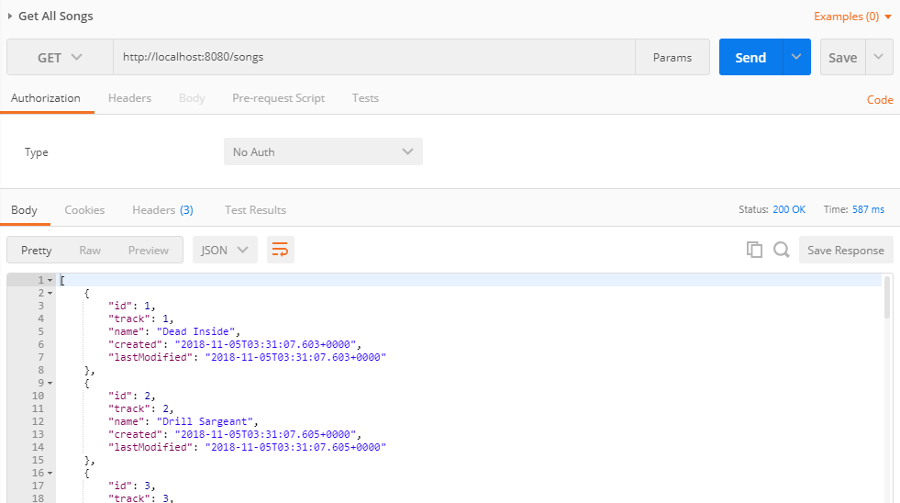

**SONG NOT FOUND BY ID:**

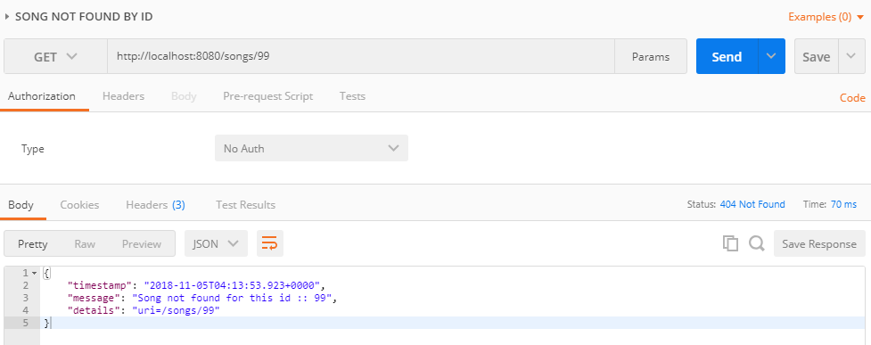

**SONG DELETE BY ID:**

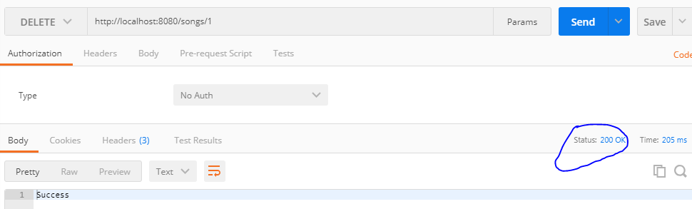

**SONG PUT/UPDATE BY ID:**

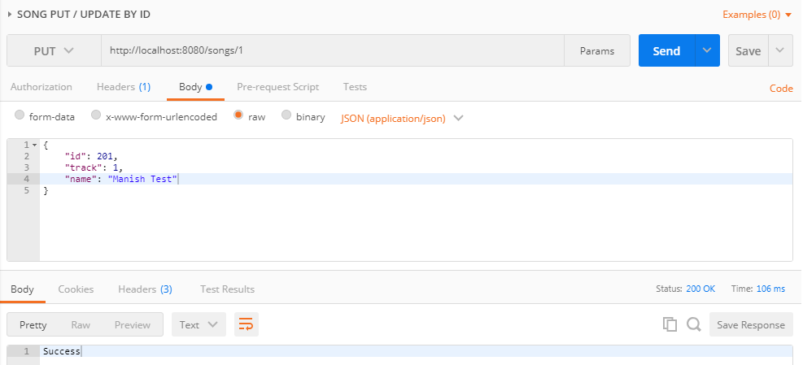

**SONG CREATE/POST BY ID:**

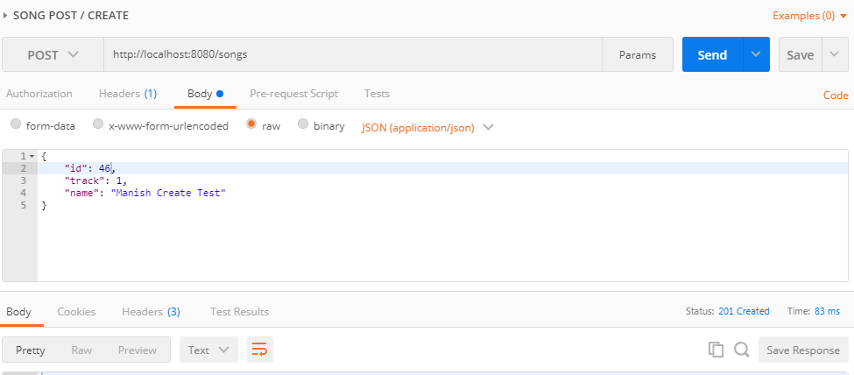

**GET ALBUM BY ID:**

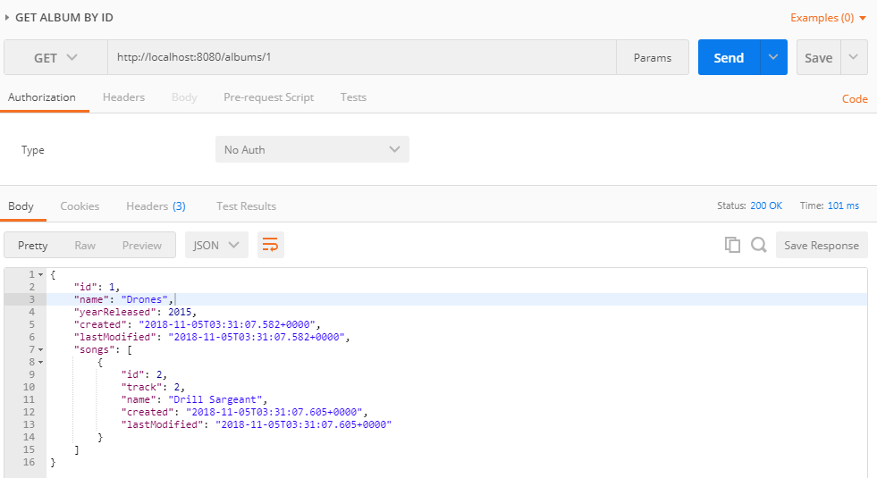

**GET ALL ALBUMS:**

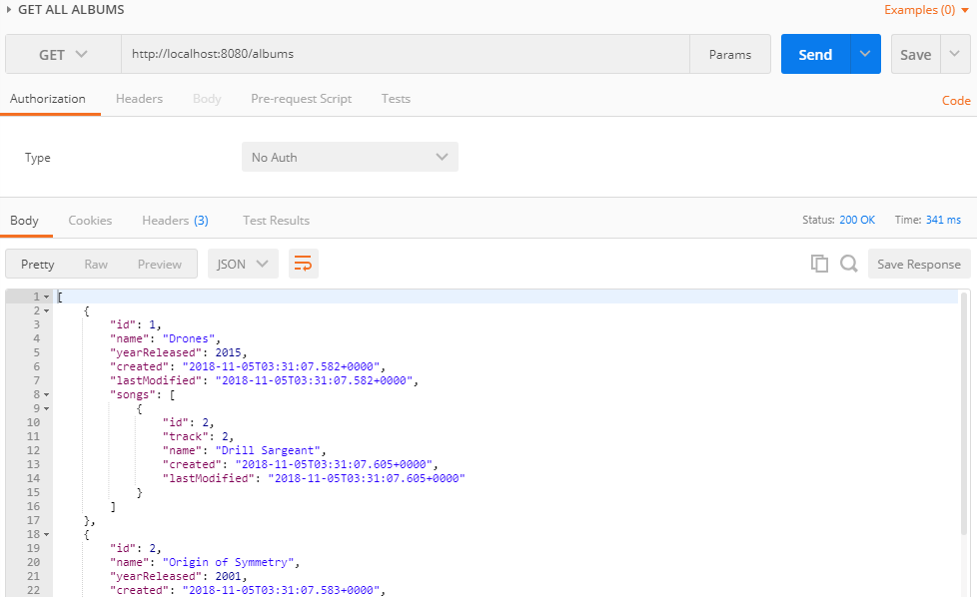

**ALBUM NOT FOUND BY ID:**

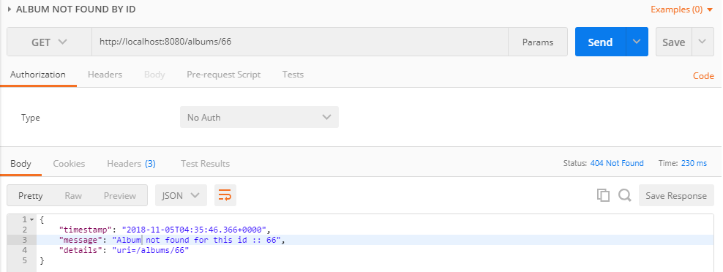

**ALBUM DELETE BY ID:**

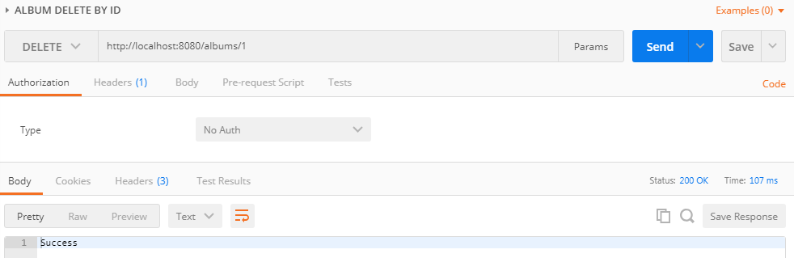

**ALBUM PUT/UPDATE BY ID:**

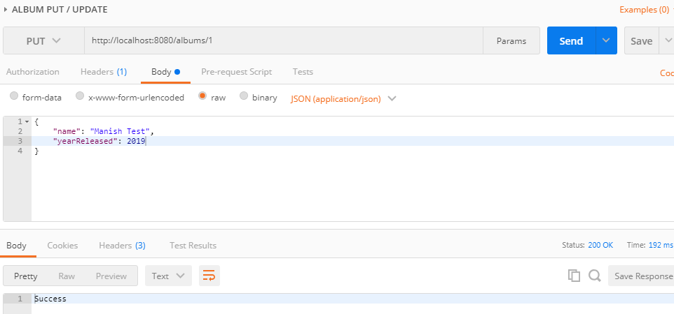

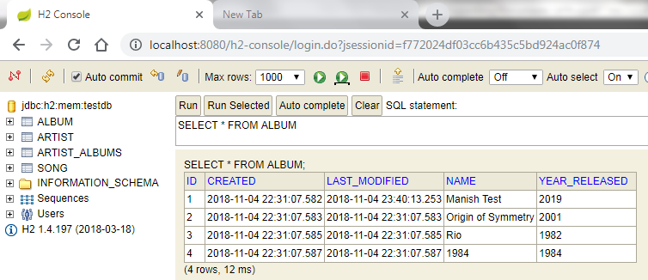

**ALBUM CREATE/POST:**

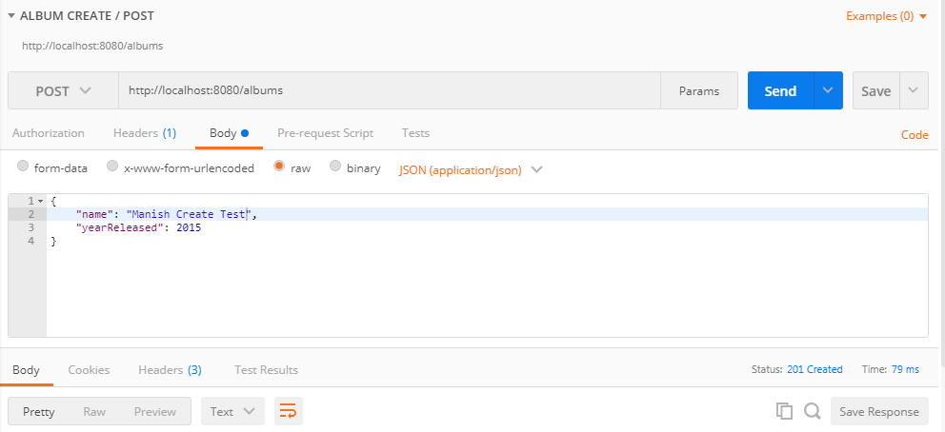

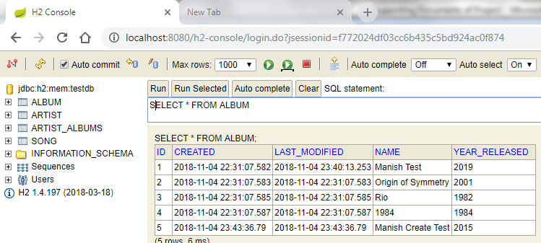

TODO: to write more unit test cases, when time permits.

